Creative Company Administrator

Welcome to The Nornen Project CIC
We’re thrilled that you’re interested in joining us and we can’t wait to find out more about you!
To access this information in another format, please visit our website: nornen-project.co.uk/work-with-us.
The following formats are available:
Easy Read (PDF)
Written English (PDF & Word)
Spoken English Video
BSL (British Sign Language) Video
Need another format? Please contact us: nornenproject@gmail.com Ready to find out more? Read on!

Contents

1... Welcome
2... Contents and Key Dates
3... About Us - Who are we?
4... About Us - Our work at a glance... 5... About Us - Right now
6... About Us - Governance & Policy
7... Role Overview
8... Job Description
9... Job Description continued
10... About You
11... How to Apply
12... Interview

In a hurry? Check out the pages in bold.

Key Dates

Deadline for applications: 11:59pm Sunday 4th October 2026

Interviews: Online, week commencing 19th October 2026

Start date: Early November 2026

About - Who Are We?

We are The Nornen Project CIC, based in Burnham-on-Sea, Somerset.
We began life with one purpose: to investigate, share and celebrate the story of the Nornen shipwreck with the very community that prevented a perilous journey from becoming a full-blown tragedy in 1897. We wanted to capture people’s imaginations, remind them of our rich heritage, and challenge preconceived ideas about who theatre can be for.
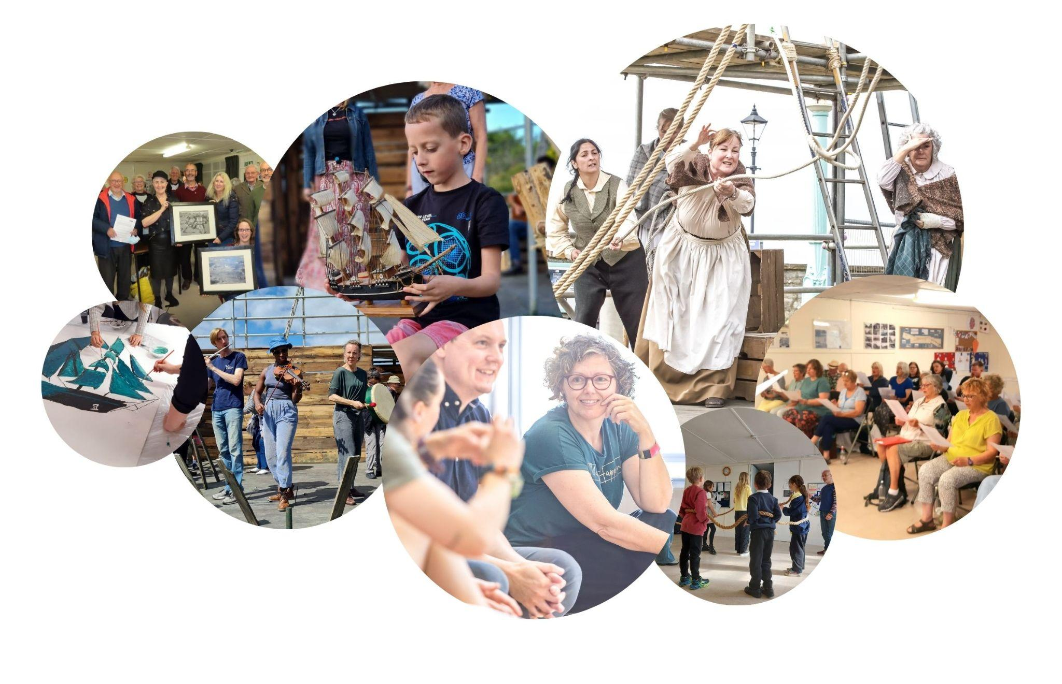
We received a phenomenal response to our inaugural outdoor theatre production, All Hands!, which brought this incredible tale to life in 2023. Today, The Nornen Project CIC continues to explore, share and celebrate Somerset's rich local history, placing our community at the heart of what we do.

About Us - Our Work At a Glance
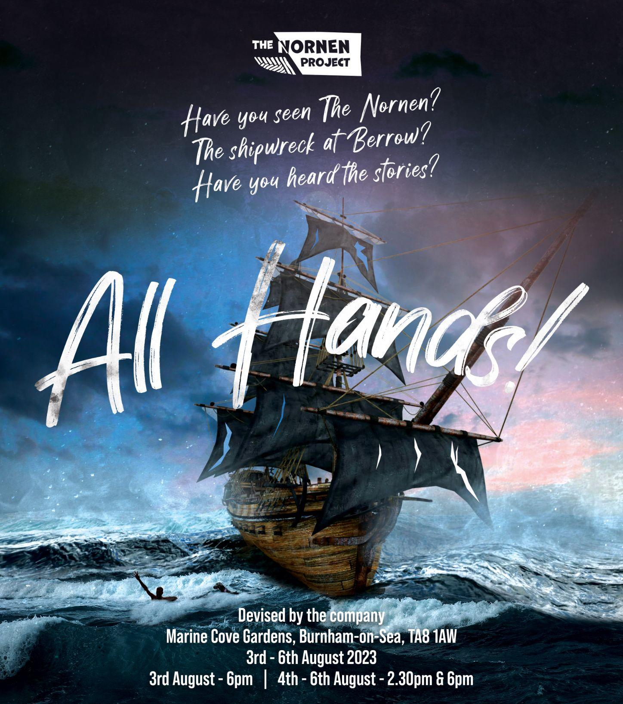
“All Hands! is an energising triumph” Fine Times Recorder
"I have to say, this project has been incredibly welcoming and friendly towards me. From the moment I joined, I felt a sense of warmth and inclusivity that I haven't experienced before.” Community Cast Member

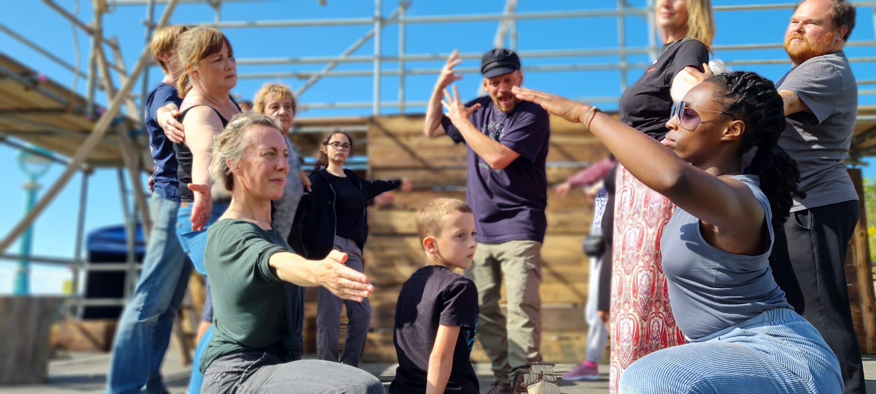
“That was simply BREATHTAKING! What an ensemble, what storytelling, what an atmosphere! Congratulations on producing such a magnificent show. Feeling completely inspired!!” Audience Member

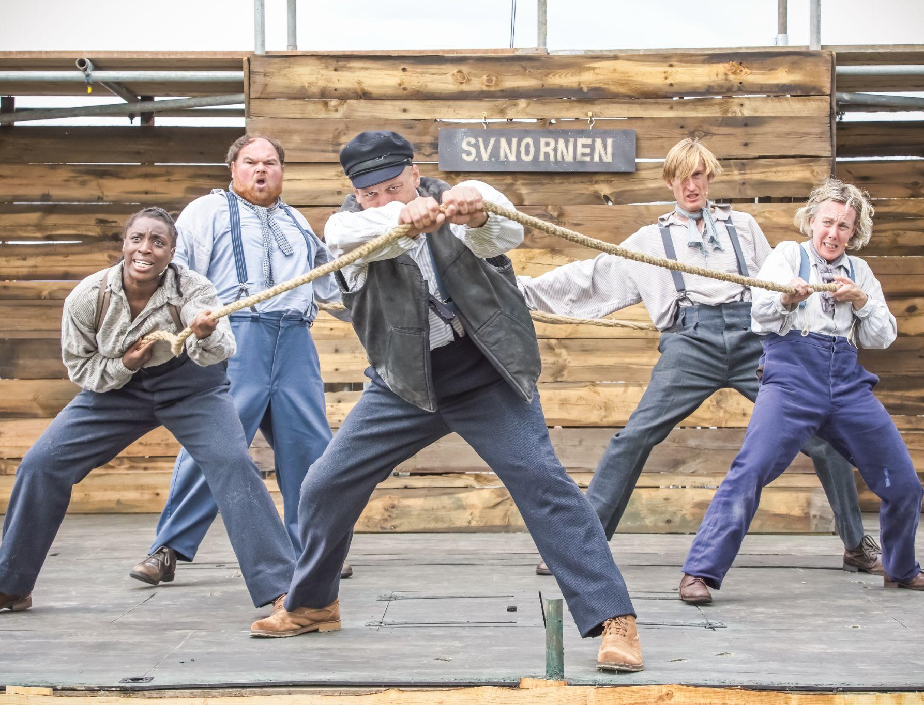
“You have achieved something very special. The performance was amazing! Not only that but you created a wonderful opportunity for community engagement at every level. We all felt part of the whole process. Everyone is talking about the play and how brilliant it was. Congratulations!” Mayor Lesley Millard

About Us - Right Now
This is an exciting time for us: we are undertaking a significant period of organisational development in order to move from a one-off project to a company able to deliver a long-term programme of activity. We are ambitious and strategic with our planned development, working with a range of partners to achieve our aims and ensuring that we stay true to what’s important to us:
1. Our community is at the heart of our activities, from programming to production.
2.We ensure that everyone has access to our theatre, heritage and arts activities.
3.We create an environment in which those who engage with us feel safe and able to be their full selves.
4.We embed inclusion in everything we do: anyone who wants to engage with us can.
This is an opportunity to join an open and inclusive theatre company at a crucial time in our life, supporting the Directors to shape our very foundations. Your contribution will go beyond keeping on top of the inbox, and will make a very real difference to the company, the artists we engage and the community we serve. We can’t wait to meet you!
Founding Director & Producer
Corrinne Curtis
Company Directors
Daniel Hawthorne and Sami Green
nornen-project.co.uk

About Us - Governance & Policy

Our Board
Our Founding Director is supported by 2 more Directors and 2 Members. The Board oversees compliance and accountability, and supports the Founding Director to steer the company.
Equal Opportunities
We're an equal opportunities employer and are especially keen to hear from candidates from underrepresented backgrounds, such as:
- deaf, neurodivergent and disabled people
- people from the global majority
- people from the LGBTQIA+ community
- people from working-class or low-income backgrounds

Not sure you tick every box? We'd still love to hear from you.

Safeguarding
We are committed to safeguarding children and adults at risk. This role may involve contact with these groups, so the successful candidate may be asked for a DBS certificate.
Data Protection
Your application information will only be used for recruitment purposes and held securely in line with UK GDPR. If you're successful, your application will form the basis of your personnel record. We won't share your data with third parties without your consent, except where required by law.
Safer Recruitment
Any offer of work is subject to satisfactory references and confirmation of your right to work in the UK.

Role Overview

Role: Creative Company Administrator
Reporting to: Founding Director
Fee: £175 p/day, paid monthly, expenses by agreement
Hours: Equivalent of 1* day (8 hours) per week, worked flexibly *potential to increase to 2 days per week, subject to funding
Start date: Early November 2026
Contract type: Self-employed Freelance
Contract length: 6 months*
*potential to increase to 12 months, subject to funding and by mutual agreement - to be discussed after first 3 months
Location: Remote working, with some travel required on occasion during project delivery
Purpose: To support the Founding Director and wider team in the day-to-day running of the company, ensuring strong administration, governance, and compliance, while also contributing to the company’s creative, inclusive and community-focused way of working. The role expands the company’s capacity so the Founding Director can focus on strategic, creative and leadership responsibilities.
The role is a blend of:
- Company administration and governance
- Compliance and policy tracking
- Access and inclusion-focused admin
- Light creative and strategic contribution

Job Description - What You’ll Do

You’ll be involved in shaping this role to meet the company’s needs as we evolve. That means that the priorities will change over time, so below is more of a flavour of the kinds of tasks you might expect to do as the role grows. Don’t worry, we won’t be expecting all of this at once!
Company & Board Administration
- Liaising with board members, collaborators and partners.
- Setting up, coordinating meetings and minuting meetings.
- Collating data to feed into board & funder reports.
- Helping maintain an overview of budgets, fundraising targets, application deadlines, tasks etc.
Communication & Enquiries
- Overseeing the company inbox: filtering incoming newsletters, sharing opportunities, and responding to general enquiries.
- Acting as a friendly first point of contact for applicants, partners and the public.
- Triaging or responding to press enquiries.
Systems, Documents & Governance
- Helping to manage and improve organisational systems and inventories, including shared Google Drive folders.
- Maintaining and updating key documents, such as: policies and procedures, company assets list, and partners list, including logging review dates and flagging when action is needed.
- Maintaining an effective personnel filing system and helping ensure HR processes are fit for purpose.
- Supporting with the company Risk Register and helping us stay on top of key deadlines (e.g. Companies House filing).
- Monitoring changes to relevant laws, regulations and funder requirements.
Recruitment, HR & Volunteers
- Supporting recruitment processes: logging applications, emailing applicants, and coordinating interviews/auditions.
- Helping to ensure reasonable adjustments and access needs are met, including support with creating accessible recruitment and induction materials (e.g. BSL, easy read, social stories).
- Helping the team to recruit and coordinate volunteers during projects.
- Coordinating and tracking team training.
Projects, Community & Inclusion
- Liaising with artists, collaborators, schools and community organisations.
- Helping us avoid scheduling clashes by keeping an eye on local events and activity.
- Supporting the development of social story packs and inclusion resources for in-person and online activity.
- Embedding access and inclusion across administration and communication.
Website, Social Media & Fundraising Support
- Keeping an eye on the website and supporting simple updates to information.
- Doing light social media monitoring, particularly around enquiries or key updates.
- Supporting with funding applications and reporting, such as tracking deadlines and gathering supporting evidence.
Creative & Strategic Input
- Acting as a sounding board for new ideas and projects.
- Contributing to conversations about how we work, our ethos, and ways to better serve our communities.
- Suggesting artists, partners or approaches that might support our aims.

About You

We’re interested in how your skills, values and experience align with this role, rather than simply a perfectly matching CV.
You are likely to:
- Have experience in administration and/or coordination (arts, charity, community, education, or similar).
- Be organised, good at managing your own workload, and comfortable juggling different tasks.
- Be a clear communicator and confident dealing with people.
- Have excellent attention to detail, especially in documents, emails and record-keeping.
- Be comfortable using digital tools (email, shared drives, basic docs/spreadsheets, online meeting platforms).
- Care deeply about access, inclusion and equity, and be open to learning more about best practice.
- Be warm, welcoming, and respectful, and able to handle confidential information appropriately.
- Be happy working remotely and as part of a small, collaborative team.
- Be committed to upholding GDPR, Safeguarding and other key policies.
It would be a bonus (but not essential) if you:
- Have experience in a theatre, arts, or community setting.
- Know the Greater Sedgemoor area, especially Burnham and Highbridge, or have experience working with socioeconomically and/or culturally deprived communities.
- Have some experience with governance, HR processes, volunteer coordination, fundraising or basic finance admin.
If you’re not sure you meet all of the criteria but feel excited about the role and our values, we’d still like to hear from you.

How to Apply

We recognise that there are many barriers to recruitment, not least the amount of time and energy it takes to put together an application. Please know that we would rather hear from you imperfectly than not at all. Our priority is to get a flavour of the skills, values and experience that you can bring to the table.
Please include:
▢ How you match the criteria in the “About You” section above
▢ What interests you in the role
▢ Your name, contact details and CV
▢ Whether you are registered self-employed (or willing to be)
▢ Where you are based
▢ Confirm you have completed our Equal Opportunities survey
You can present this information in your preferred format, such as:
- written covering letter / bullet-point list
- video / audio application*
*You can use file sharing platforms such as WeTransfer.com, or streaming sites such as YouTube and email an open link to us.
Please send your application to Corrinne at
nornenproject@gmail.com with the subject heading “Creative Company Administrator Application - YOUR NAME”.

DEADLINE: 11.59pm, Sunday 4th October 2026.
Missed the deadline? It happens. Whilst we can’t guarantee that we’ll be able to consider applications received after this time, if you’re excited about the role and our work, please do get in touch and we’ll let you know if we can.
Interview
Interviews will take place online week commencing 19th October.
If you already have time/date restrictions that week, do let us know in your application.
You will meet with Founding Director Corrinne Curtis and another member of the team. We will let you know in advance what to expect, including interview questions.
If invited to interview, please do let us know any access requirements you may have as soon as possible. We want to make this a positive experience where you can feel at your best.
Got any questions?
Please do drop Corrinne an email at nornenproject@gmail.com.

